

CSE370 : Database Systems
Project Report
Project Title : Health Service System

Group No : 08, CSE370 Lab Section : 08, Fall 2024
ID | Name | Contribution
22101882 | Rafia Jahan Prottasha | Dashboard, Admin
22101150 | Md Mubin Ibne Azad | Staff, Database
23241047 | Md Readus Shalehin | Homepage, connections

Table of Contents

Section  No | Content | Page No
1 | Introduction | 3
2 | Project Features | 4
3 | ER/EER Diagram | 5
4 | Schema Diagram | 6
5 | Frontend Development | 7-9
6 | Backend Development | 10-12
7 | Source Code Repository | 13
8 | Conclusion | 14
9 | References | 14

Introduction

Health Service System is a web-based project aimed at automating and simplifying the appointment booking process of doctors, ambulance service and finding blood for a hospital. It offers an efficient platform for doctors, staff, and patients to find each other, and offers booking appointments based on availability, and diseases. Additionally, it also offers ambulance service for patients. Furthermore, it also offers a blood bank where patients can collect blood bags or normal users can donate blood bags. Here, Staff will take care of the patients and meet their requirements. The project is ideal for modernizing hospital services and improving patient satisfaction through seamless digital solutions.

Project Features

Patients can only log in/ register and update their information
Staff can handle-
- Create or update appointment
- Update blood bank
- Update doctor
- Update normal users
- Update hospital location
- Update or create patient details
- Update or create staff details

Admin can handle all the staff’s works and additionally
- Update Admin details
- Update Authentication
- Update All Users

Normal Users can donate blood to blood banks

Doctors can-
- Update their info
- Check upcoming appointments
- Delete their info

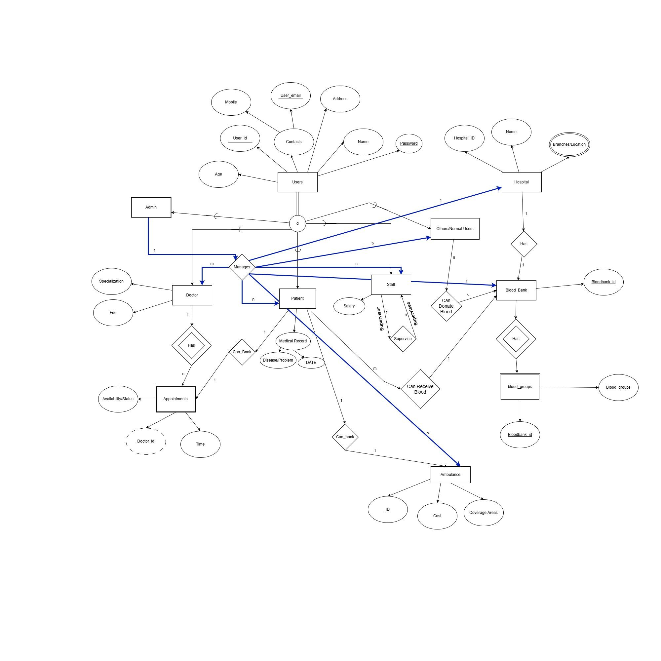
ER/EER Diagram

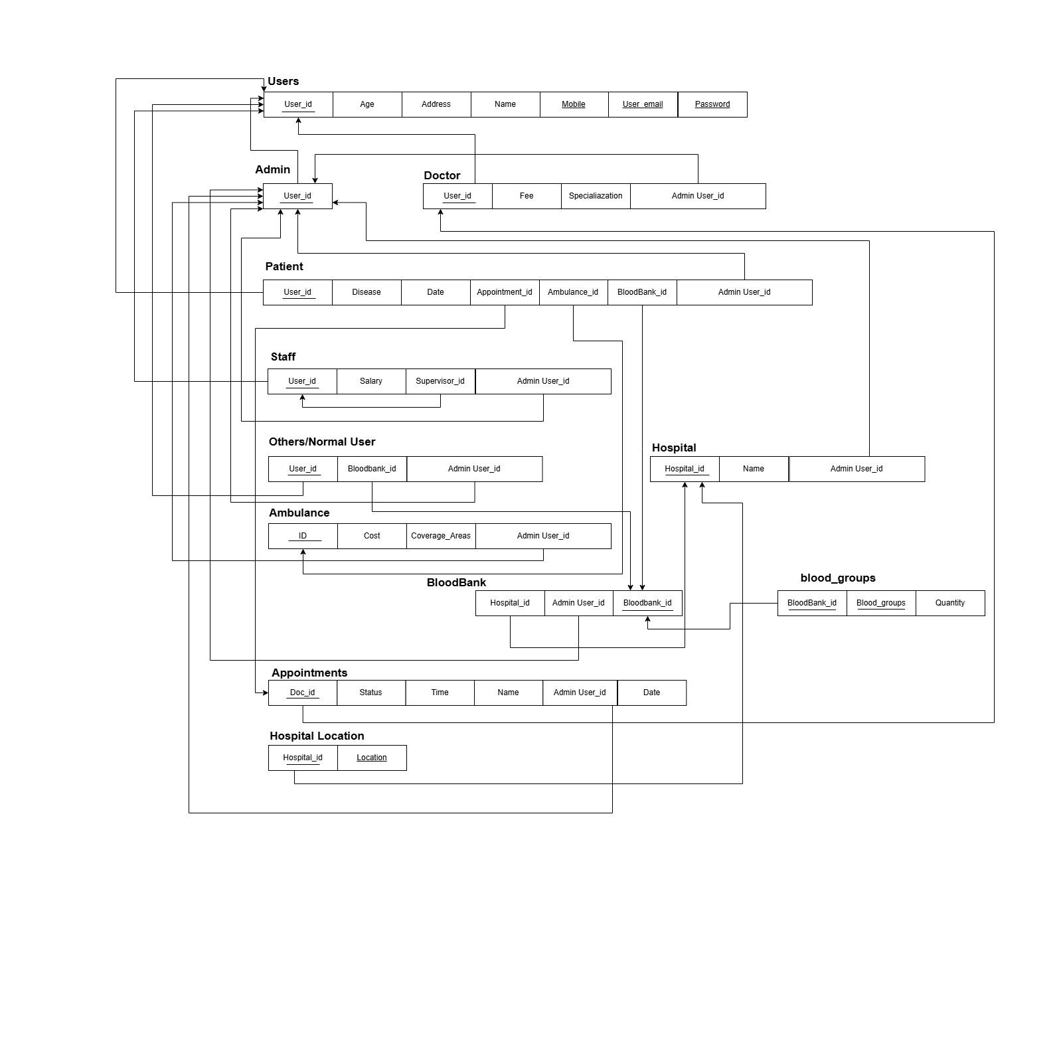
Schema Diagram

Frontend Development

Contribution of ID : 22101882, Name : Rafia Jahan Prottasha

We used html and css to design each of the pages in the health service system. For designing the dashboard, we used multiple bootstraps to enhance the design, using css helped us to style and format the layout. The profile page for users was rather plain to update their information only.
Admin Dashboard
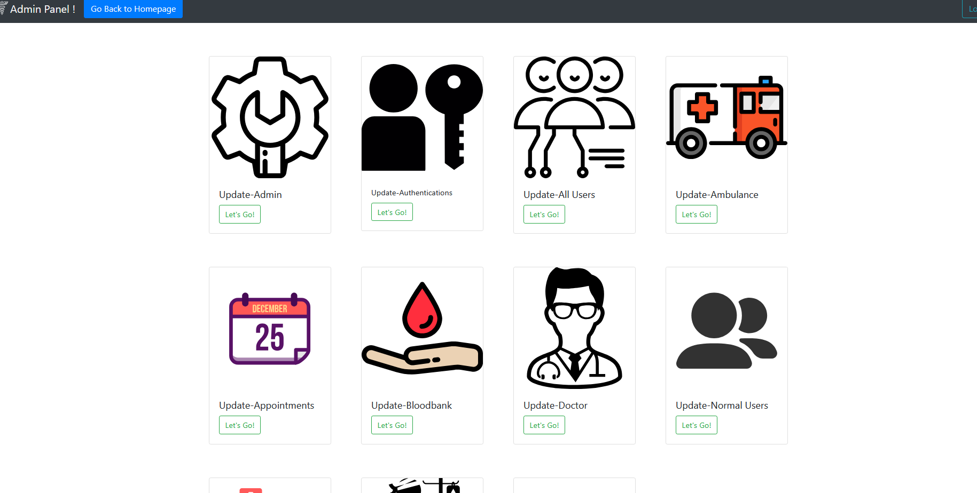

Profile Page
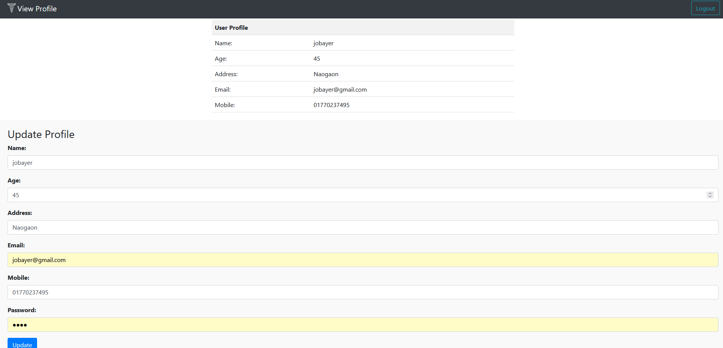

Contribution of ID :22101150, Name : Md Mubin Ibne Azad

For creating a clean, responsive and user friendly interface, css was put into use. Furthermore, for creating a consistent and responsive design, we used bootstrap in most of the pages. We customized it in a way so that it takes less resources and loads up fast. As the login page and sign up pages used multiple bootstrap items, it was designed.

Log In
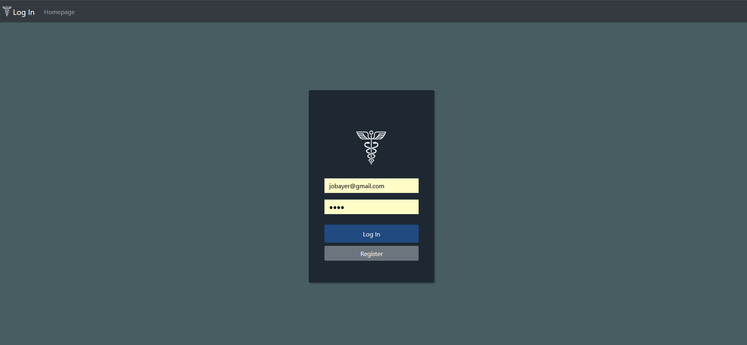

Sign Up
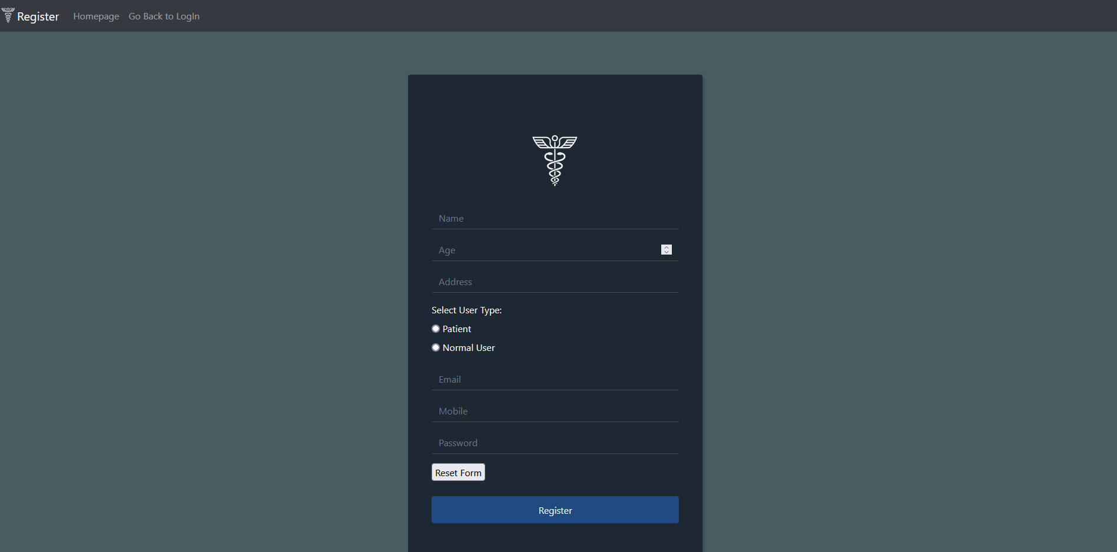

Contribution of ID : 23241047, Name : Md Readus Shalehin
The homepage design was done to provide fast, and necessary information to the visitors. On the top left, the logo is always being displayed. Most used services are available on the front. To make it more appealing, several moving images along with text and static images are also present in the homepage. Furthermore, the doctor panel is limited only with updating their info, checking their appointments and the option to delete their information.This combination of technologies helped us build a simple yet effective interface, enhancing both usability and visual appeal.

Homepage
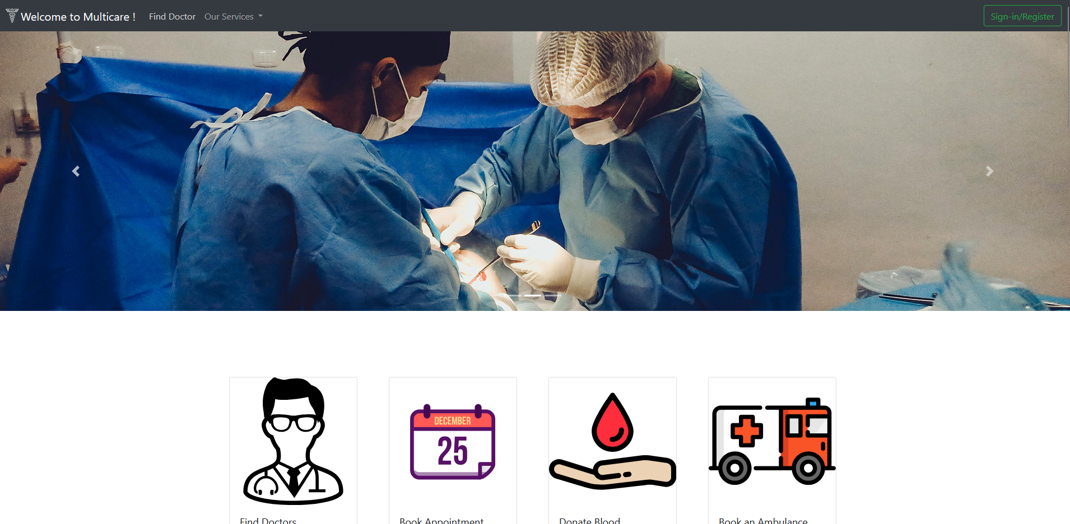

Doctor Panel

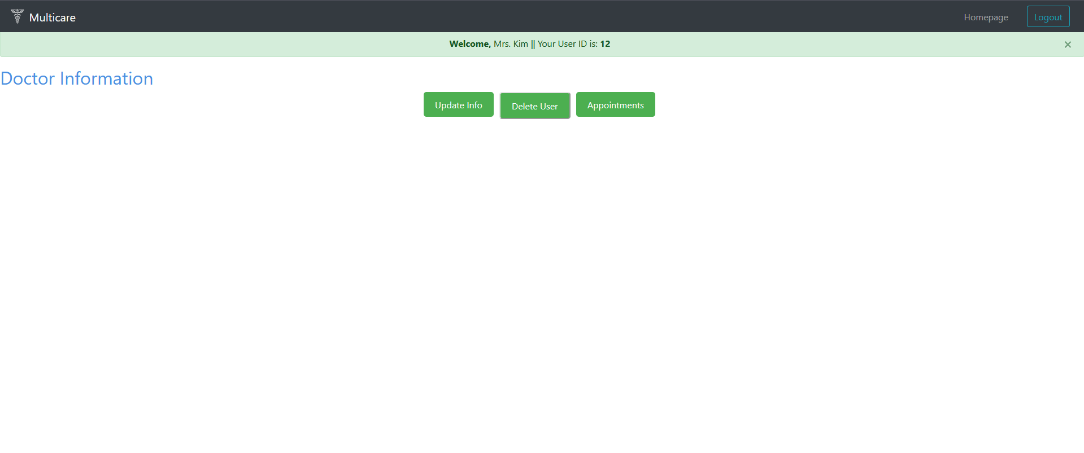

Backend Development

Contribution of ID : 22101882, Name : Rafia Jahan Prottasha

For the backend development of the Health service System, we utilized PHP to handle server-side logic and manage interactions between the frontend and the database. PHP enabled us to process user requests, manage sessions, and dynamically generate content based on user input. As Admin has the most power over the system, admin panel has the most options, while the super admin has unique user id (-1)

PHP file of Admin panel
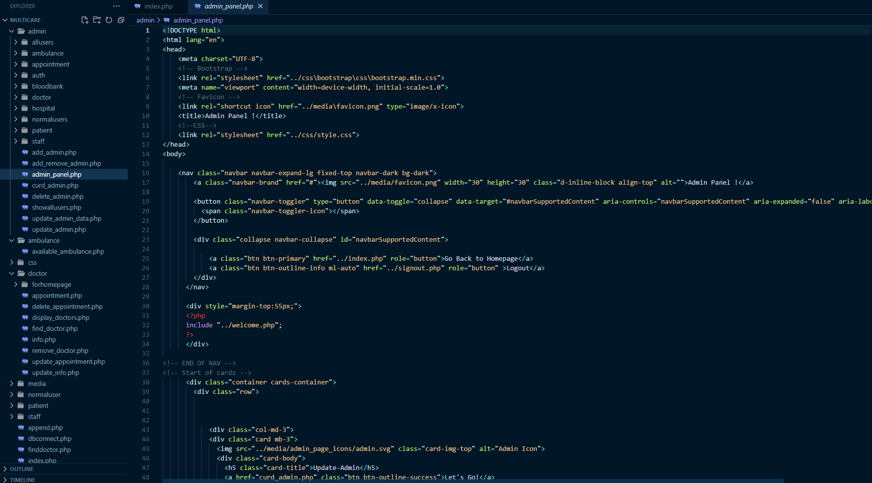

PHP file of append
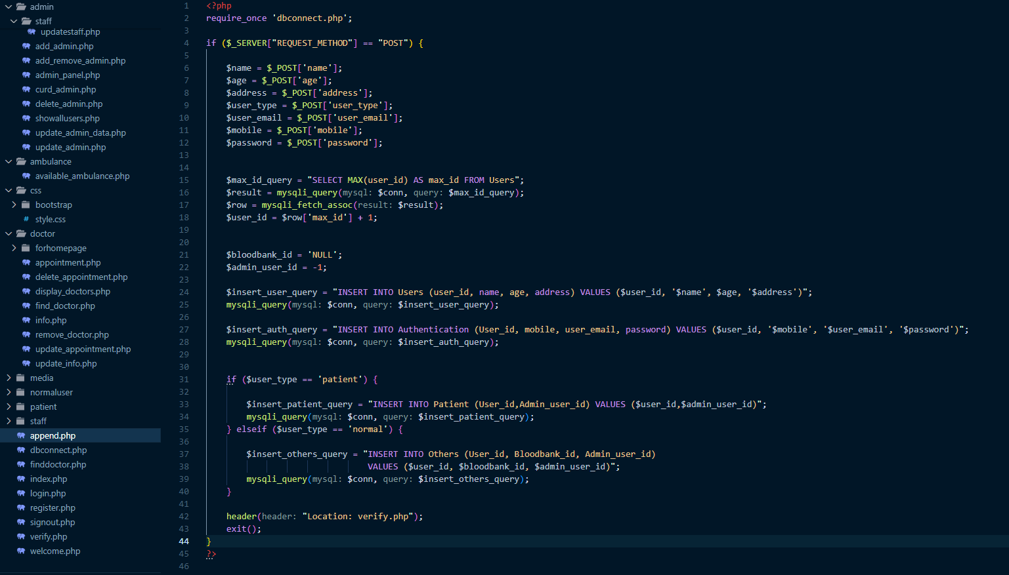

Contribution of ID : 22101150, Name : Md Mubin Ibne Azad

We integrated a SQL database to store and retrieve critical data, such as user details, consumption records, and billing information. The SQL queries were used to efficiently fetch, insert, update, and delete data from the backend

PHP File of Staff Panel
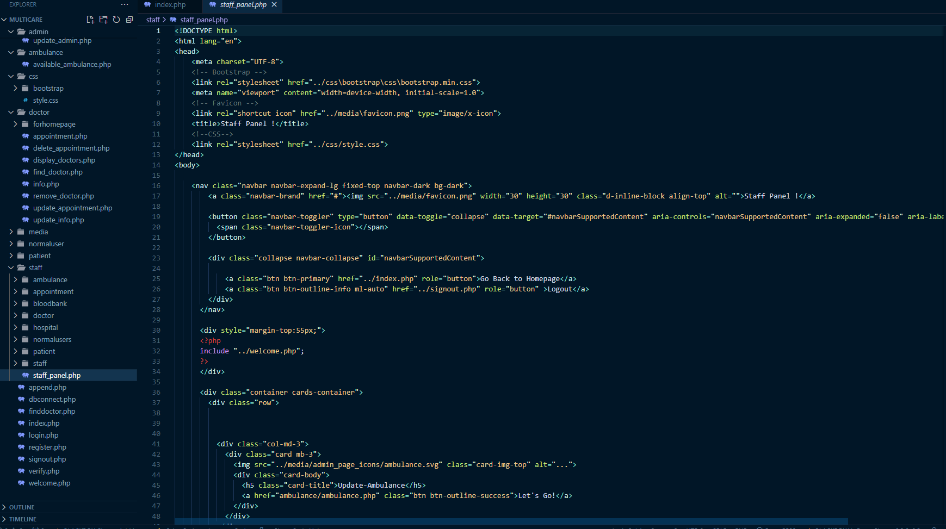

PHP file of Database connection
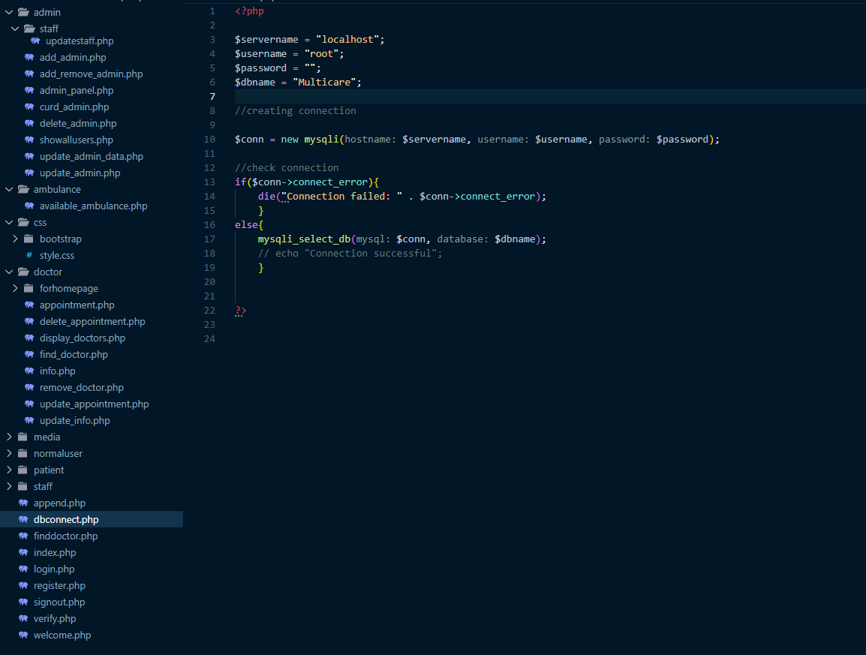

Contribution of ID : 23241047, Name : Md Readus Shalehin

Login page had multiple place to go to, as there are different type of users. Depending on the user, it would take them to different interfaces. The combined usage of PHP and SQL ensures seamless communication between the system's interface and the database. This setup provided a robust, secure, and efficient backend to support the application's functionality.

PHP file of Login
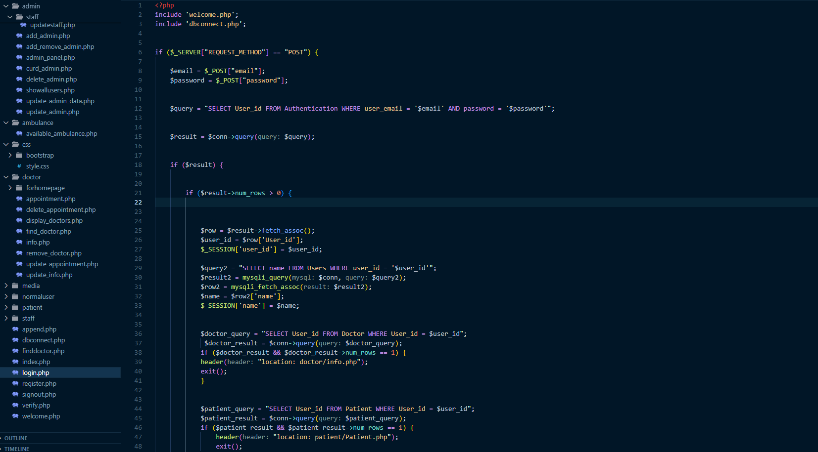

Source Code Repository

https://drive.google.com/file/d/1v1Vv8tRWwBN2OLHe7OhfjQt1jRTMeiY0/view?usp=drive_link

Conclusion

In conclusion, the health service system project makes an efficient, fast and modern way for patients, staffs, and doctors to provide and receive service. The frontend, built using HTML, CSS, and JavaScript, ensures a seamless user experience, while the backend, powered by PHP and SQL, securely manages data and server-side operations. Apart from appointments, the normal users can donate blood to blood banks and call an ambulance. This project is designed for the staffs to help the patients fill up their information. Overall, the system delivers a modern, digital solution for efficient treatments, and other health services.

References

- https://cdn.jsdelivr.net/npm/bootstrap@4.4.1/dist/js/bootstrap.min.js
- https://cdn.jsdelivr.net/npm/popper.js@1.16.0/dist/umd/popper.min.js
- https://code.jquery.com/jquery-3.4.1.slim.min.js

